**DevRishi(देवऋषि)**

**Team Members:-**

1. **Atharva Deopujari (Lead) (BT22ECE003)**
2. **Vansh Bhavsar (BT22ECE001)**
3. **Kirtan Bhavsar (BT22ECI007)**
4. **Vipin Mishra (BT22ECI019)**
5. **Kushagra Srivastava (BT22CSE139)**
6. **Akshaya Siri Mudragada (BT22CSE056)**

**Introduction :**

In the fast-paced world of technology and healthcare, the integration of artificial intelligence (AI) has revolutionized the way we access information and services. Chatbots, in particular, have emerged as a versatile tool for enhancing customer experience and solving real-world problems. One promising avenue for the development of a profitable startup is a chatbot that suggests Ayurveda remedies. Ayurveda, an ancient Indian system of medicine, offers holistic solutions to various health issues. In this essay, we will explore how a chatbot focused on Ayurvedic remedies can evolve into a successful and profitable startup.

**The Ayurveda form of cure:**

Ayurveda, which means the "science of life," has seen a resurgence in popularity in recent years. People are increasingly seeking natural and holistic approaches to health and well-being. Ayurveda, with its emphasis on personalized, holistic treatments, aligns perfectly with this growing trend. However, accessing Ayurvedic knowledge and remedies can be challenging for many individuals. This is where a chatbot dedicated to Ayurveda can bridge the gap.

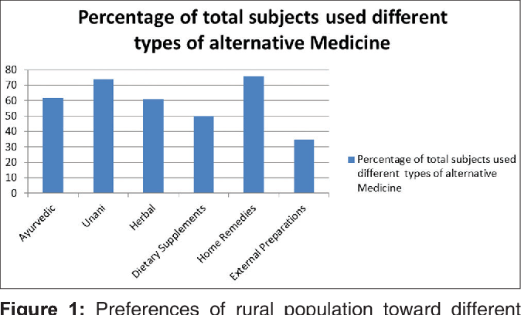

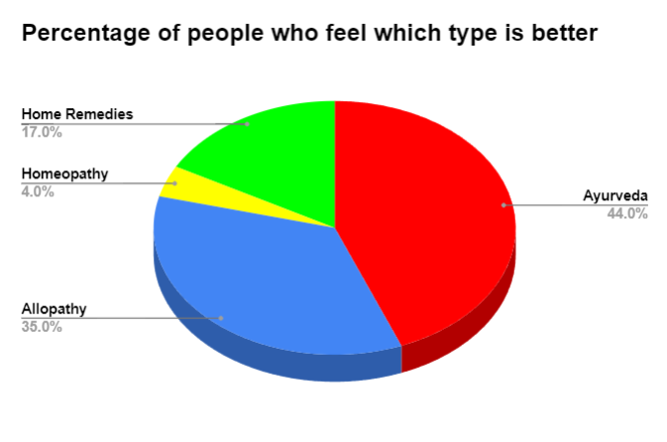

**Why is Ayurveda Medicine the best ?**

The assertion that Ayurvedic medicine is the "best" is subjective and depends on individual preferences, health needs, and cultural beliefs. Ayurveda is an ancient system of medicine that originated in India and has been practiced for thousands of years. It is known for its holistic approach to health and well-being, focusing on the balance of mind, body, and spirit. Here are some reasons why some people believe Ayurveda is beneficial:

1. **Holistic Approach:**

Ayurveda considers the whole person, addressing not only physical health but also mental and spiritual well-being. It aims to achieve a harmonious balance within the individual.

1. **Personalized Treatment:**

Ayurvedic practitioners often tailor treatments to an individual's unique constitution, known as their "prakriti," which can lead to more personalized and effective care.

1. **Natural Remedies:**

Ayurvedic treatments often rely on natural ingredients such as herbs, minerals, and dietary adjustments. Many people prefer these natural remedies over synthetic drugs.

1. **Preventative Care:**

Ayurveda emphasizes the importance of prevention by promoting a healthy lifestyle, including diet, exercise, and stress management, to maintain overall well-being.

1. **Minimal Side Effects:**

Since Ayurvedic treatments predominantly use natural ingredients, they are believed to have fewer side effects compared to some pharmaceutical medications.

1. **Cultural and Traditional Significance**:

Ayurveda holds cultural and historical importance in India and is deeply rooted in Indian traditions and practices.

**Advantages of Devrishi Website/Software**

1. **Information about Ayurvedic Medicines:**

This website will contain the necessary information about the medicines and

it will distributed into its particular section of medicines in Ayurveda. This

is done inorder for better understanding for the student and practitioners

about our website and proper use of it.

1. **Account Creation and Login:**

Students/Practitioners will be able to create an account and later login to continue their study from where they left.Their data will be saved on their account name.

1. **Contribution Page:**

A page dedicated to contribution from doctors/students to share their knowledge with others which can later be integrated in the website.

This will also help to further enhance the database of the website.

1. **Discussion Portal:**

A portal for all the like minded students/practitioners to be able to interact with each other and discuss their favorite topic related to Ayurveda.

It will also help to build a community for ayurveda which will help to increase its awareness and popularity.

1. **Multilingual Support:**

This will change the particular site to the language chosen by the user so even a person who doesn’t have a better grasp over english can use our site.

1. **Quick Search Bar:**

This is a search bar which will guide the user for better traveling in our website it can be used even to fast search a medicine for fast use of this website.

1. **Ebooks and Pdf links:**

This website will contain E-books and Pdf links of some of the most important books used in the journey of a Ayurved student to become a doctor.

**Advantages of the Sushruta (सुश्रुत) 2.0 Chatbot**

1. **Accessibility of Ayurvedic Knowledge:**

A chatbot can serve as a virtual Ayurvedic consultant, offering easy access to a vast repository of knowledge. Users can seek information on various health issues and receive personalized recommendations based on their specific symptoms, constitution (Dosha), and lifestyle. This accessibility is particularly valuable for individuals who may not have access to Ayurvedic practitioners in their vicinity.

1. **Customized Health Plans:**

The chatbot can create personalized health plans, including dietary recommendations, herbal remedies, and lifestyle adjustments, tailored to the user's unique needs. This level of customization sets it apart from generic health advice and makes it a valuable resource for individuals looking for holistic solutions to their health problems.

1. **Continuous Engagement:**

To ensure long-term success, the chatbot can engage users in ongoing conversations. It can send regular reminders, offer progress tracking, and adapt recommendations based on user feedback and evolving health conditions. This continuous engagement not only builds trust but also keeps users coming back for more.

1. **Control over data:**

We have complete control over the data that powers our chatbot. This control extends to both the input data that influences the bot's responses and the output data it generates. We carefully curate and monitor the information sources that feed into our chatbot, ensuring that the data aligns with our ethical guidelines and quality standards as well as there is no false information.

**Monetization Strategies**

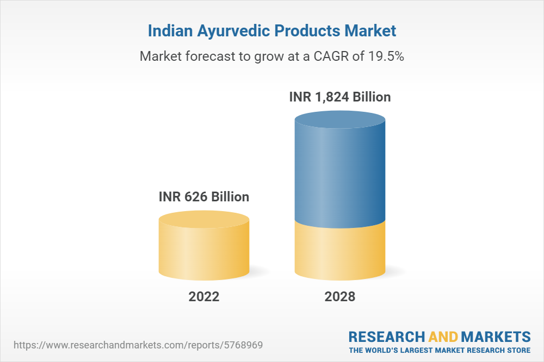

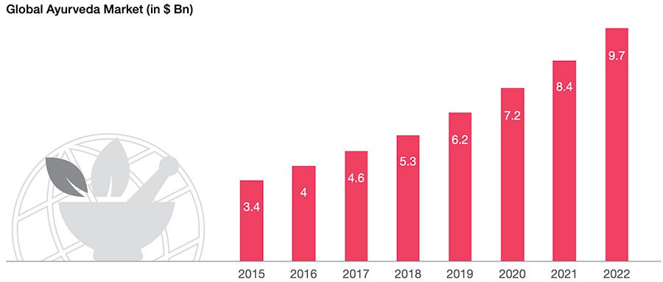

1. **Freemium Model:**

The chatbot can offer basic services and information for free, enticing users to engage with the platform. Premium features, such as in-depth personalized health plans or direct consultations with certified Ayurvedic practitioners, can be monetized through subscription models or one-time payments.

1. **Affiliate Marketing:**

Collaborating with Ayurvedic product manufacturers and suppliers, the chatbot can recommend specific herbal products and remedies to users. By earning commissions through affiliate marketing, the chatbot can generate a steady stream of income.

1. **Data-Driven Insights:**

The chatbot can anonymize and aggregate user data (with user consent) to identify health trends and preferences. This valuable data can be sold to research institutions, Ayurvedic product companies, or pharmaceutical companies seeking to develop natural remedies.

**Challenges**

1. **Building User Trust:**

Building trust in the chatbot's recommendations is crucial. Transparent sourcing of information, providing credible references, and offering access to certified Ayurvedic practitioners for consultation can enhance user trust.

1. **Scalability:**

As the user base grows, scalability becomes a challenge. Developing a robust backend infrastructure and AI systems that can handle increased user load is essential for long-term success.

**Chat box (audio and text input) :**

1. Speech recognition Model
2. Speech to text library
3. OpenAi library
4. Wikipedia library

**Fundamentals concepts**

1. **Natural Language Processing (NLP):** tokenization, stemming, lemmatization, part-of-speech tagging, and Named Entity Recognition (NER).
2. **Speech Recognition:**  basics of speech-to-text conversion, phonetics, and audio signal processing.

**Chatbot techstack:**

1. TensorFlow
2. Pytorch
3. DialogFlow
4. PyCharm
5. Jupyter Notebook
6. Google Collab
7. Python

**User interface development:**

**Frontend**

1. HTML
2. JAVASCRIPT
3. CSS
4. REACT
5. Gradio
6. Streamlit

**Backend**

1. Node.js
2. Express
3. PHP
4. Server side programming

**Data Management**

1. MongoDB or PostgreSQL -for database management.
2. GitHub
3. MySql